**Azure fundamental assignment 1**

1. What is cloud computing? What is Azure?

*Cloud computing is the provision of on-demand IT resources over the Internet. The companies that provide these computing services are called cloud service providers (CSPs). CSP charges users/organizations based on cloud resources used by different billing models. Cloud resources are resources extracted from the underlying physical hardware using a hypervisor. However, there is a lot of confusion about cloud computing because there are multiple types of services and deployment models that fall into the cloud computing terminology. This article will help you understand the basic concepts of cloud computing.*

*The Azure cloud platform includes over 200 products and cloud services designed to help enable new solutions to solve today's challenges and shape the future. Build, run, and manage applications across multiple clouds on-premises and at the edge using the tools and frameworks of your choice.*

1. How to create an Azure account list the steps and requirements?

## **Steps To Register For Azure FREE Trial Account**

1. Go to the[**Azure Home Page**](https://azure.microsoft.com/en-us/).

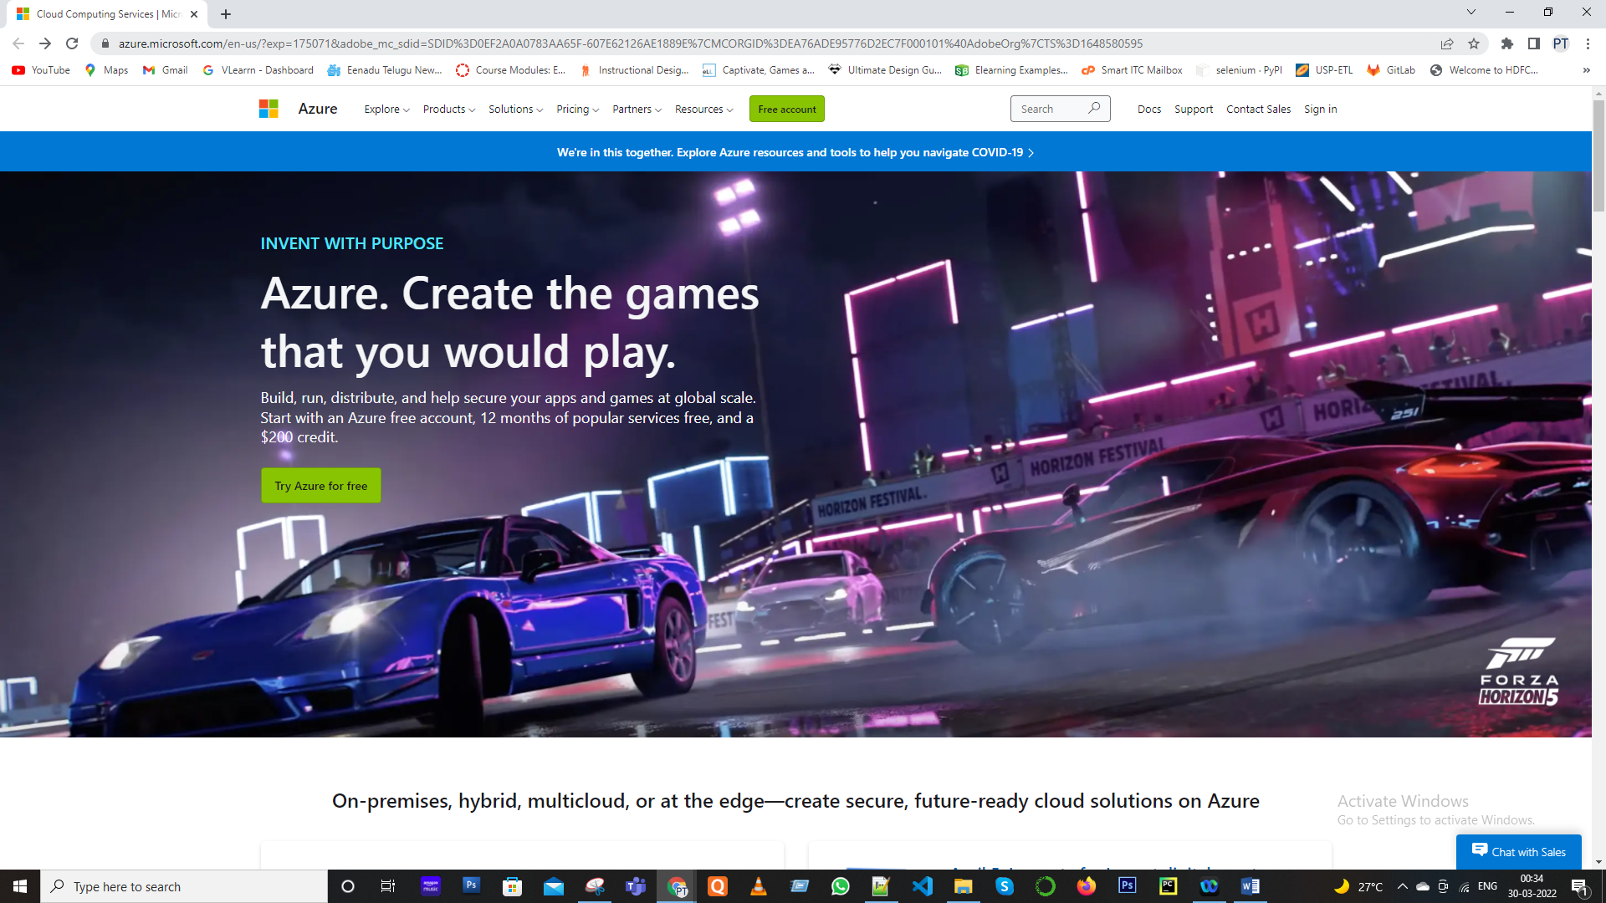

2. Click on **Free Azure Account** on the top right corner.

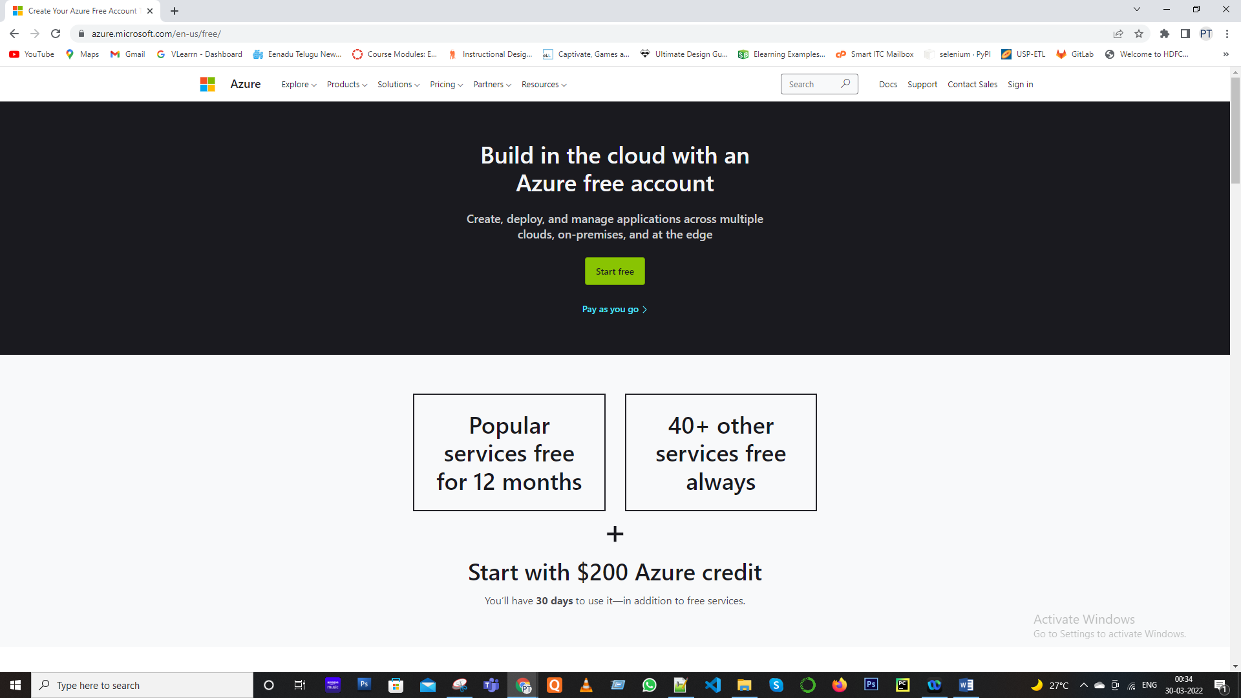

3. Click on **Start Free.**

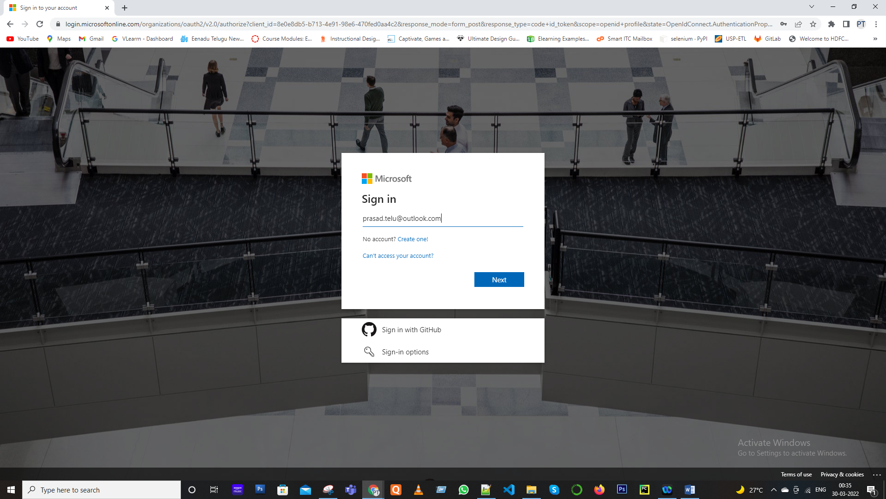

4. Sign-in/Sign-up for a Microsoft account using an email address and password.

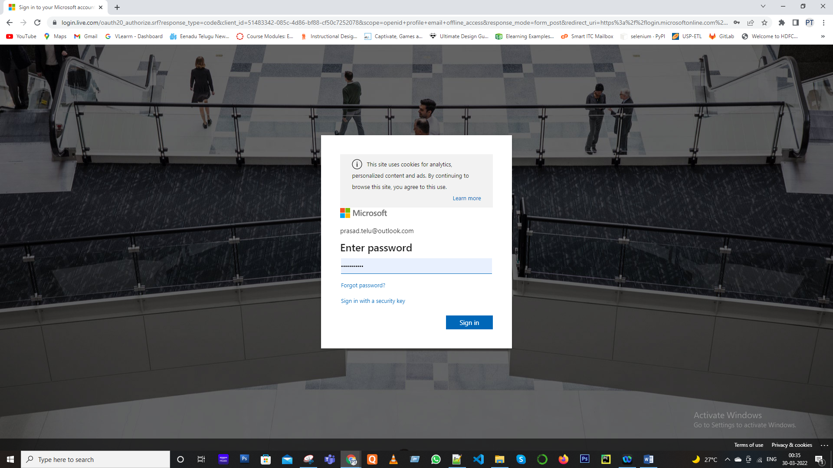

5. Enter your Country/Region and Date of Birth and click next.

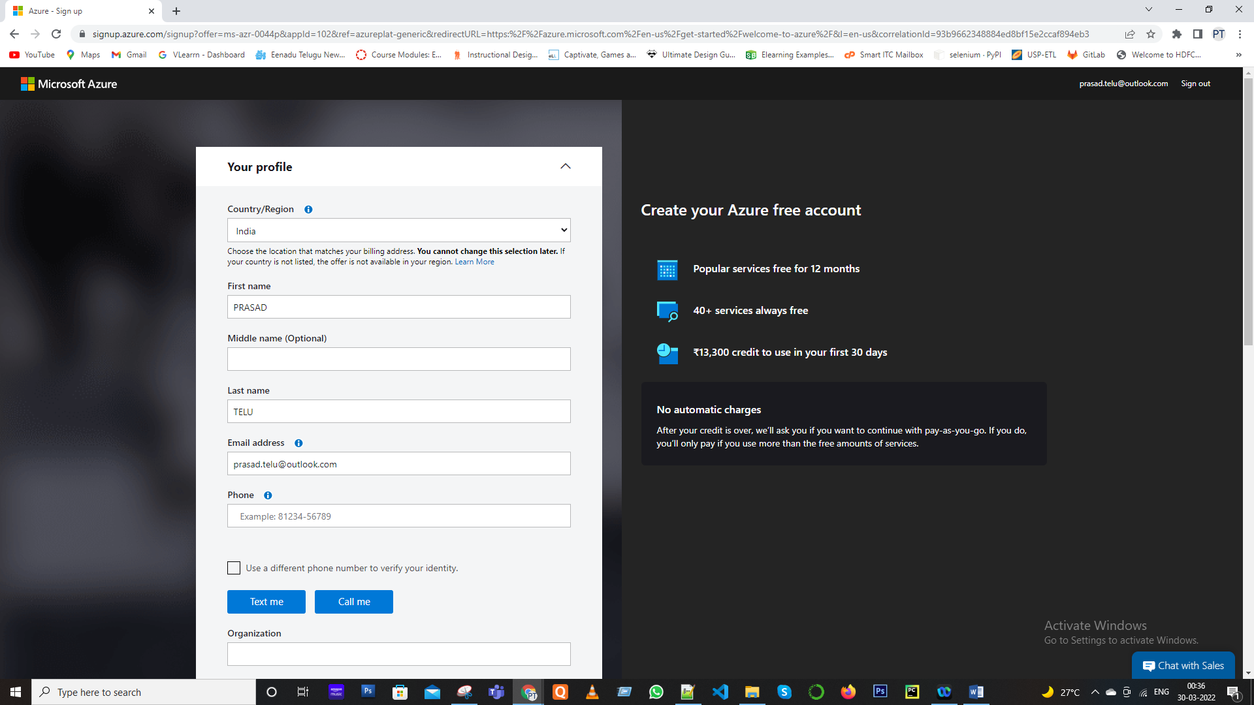

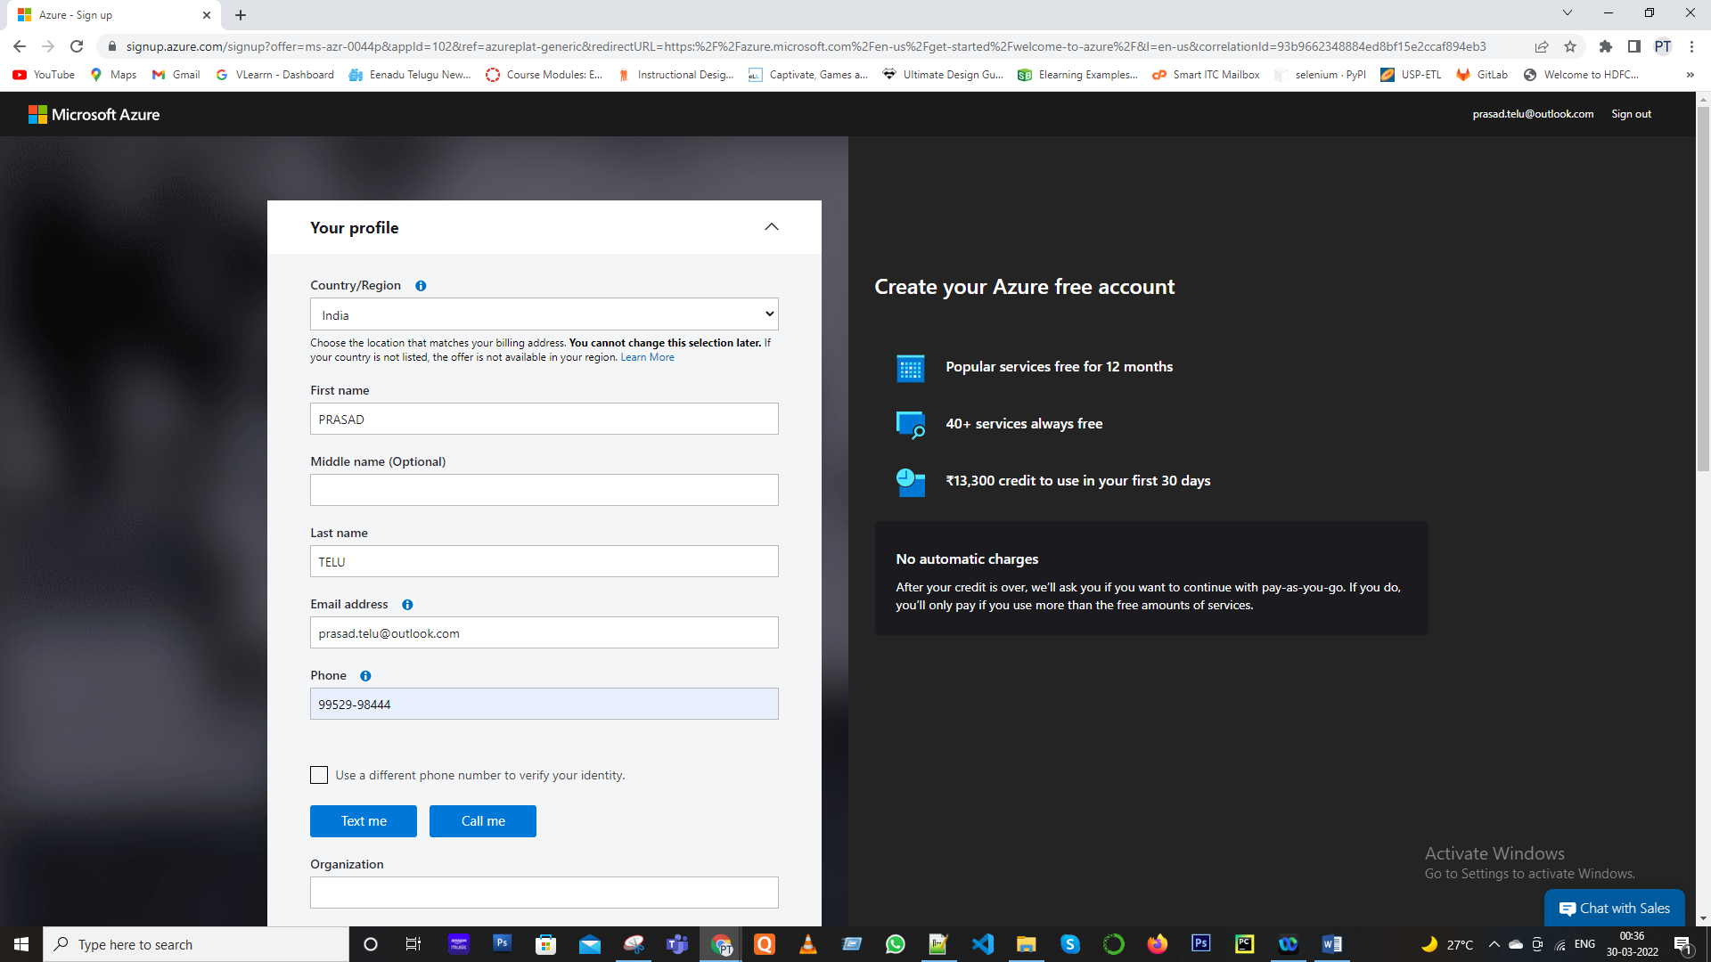

6. Enter the **verification code** received on the email address and click next.

7. Type the captcha you see on your screen and click on next.

8. You’ll be redirected to the Azure Sign-up page. Enter your Region, Name, Phone number, Email address. **Note**: You should use the same email address for Azure sign-up and for the Microsoft account.

9. Verify your phone number by clicking Text Me or Call Me and enter the verification code received.

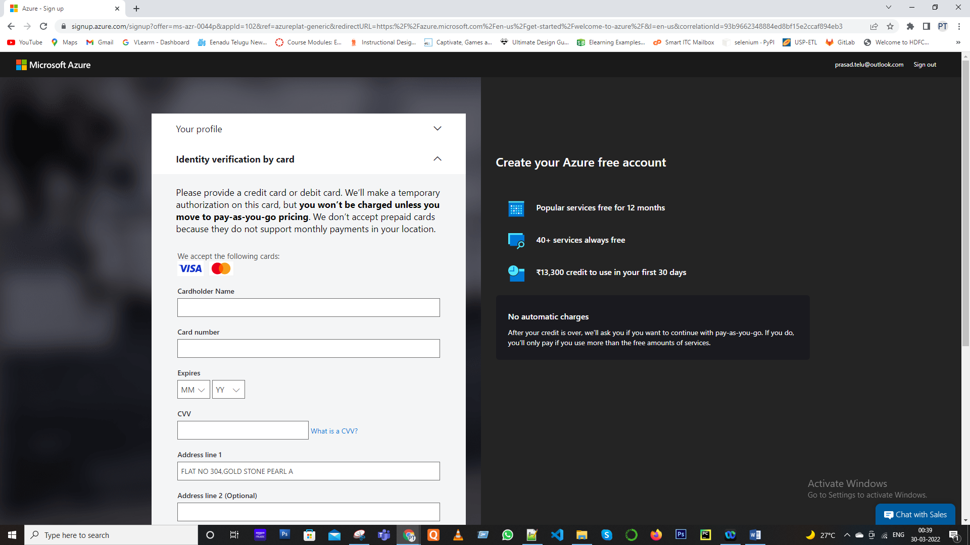

10. Enter the payment details. Make sure you have a **Master Card/American Express/ Visa Credit card** and international payments should be enabled.

11. Check the Terms and Conditions and click Sign-up.

12. You have successfully created a Microsoft Azure free account and now have a lumpsum balance of **$200**.

13. Click on **Portal** on the top right corner of the screen. You’ll be redirected to the Azure portal.

14. If you have exhausted your free credit then you have to move to the Pay as you go subscription policy.

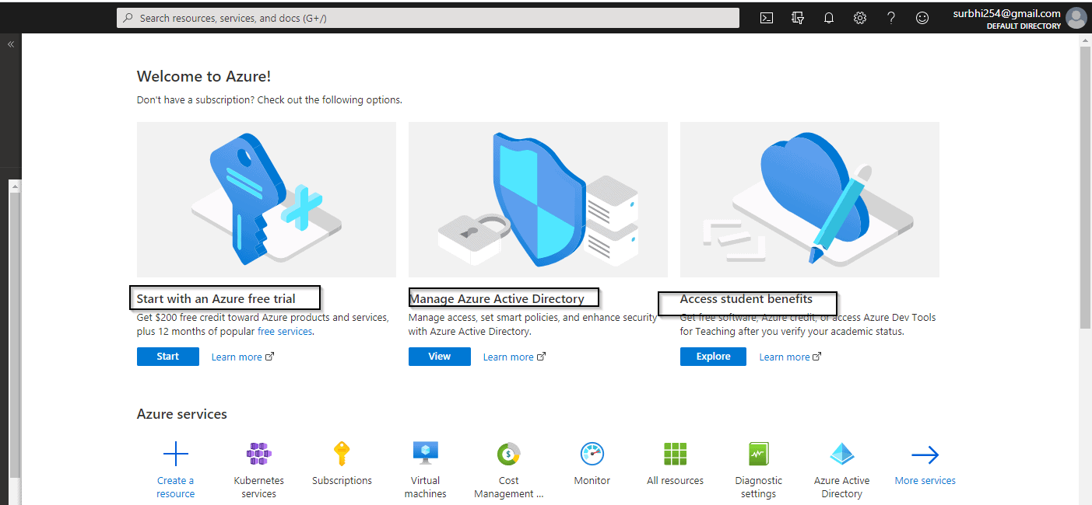

if you have crossed the limit or time limit then you will get “your subscription is disabled and cannot perform operations until its re-enabled”

You cannot create multiple Microsoft azure free accounts or after one account expires to another account for free credit of 200$ using a single Credit card.

1. Describe different types of cloud models.

*Cloud computing is a comprehensive term that includes a collection of different services aimed at creating cost-effective solutions for optimizing IT capabilities and capacity. These different types of cloud computing services are radically different delivery models, each with its own unique characteristics.*

*A set of features and control of information. Each of these cloud computing services offers a unique set of benefits and new features tailored to the specific needs of different organizations, enterprises, or enterprises. The diversity provided by different types of services makes cloud computing an efficient and viable IT solution for a wide range of users. This gives cloud computing the freedom to decide how, where, when, and how to adopt it. technology.*

*The three major cloud computing services have different characteristics, ease of use, and scope.*

|  |  |  |
| --- | --- | --- |
| *IaaS* | *PaaS* | *SaaS* |
| *IaaS uses third-party applications to provide computing resources, storage, servers, and more for your customers to use. Customers can also use IaaS to build their own PaaS or SaaS services.* | *The PaaS model relies on third parties to provide services and platforms that allow customers to build applications. The entire infrastructure and necessary tools are provided to customers over the Internet.* | *The SaaS model uses a third party to host multiple applications available to customers over the Internet. It works efficiently as a pay-as-you-go model.* |

1. Describe different cloud services.

*The four main types of cloud deployment models are private, public, or hybrid and community. The choice of the model you want depends on your specific requirements.*

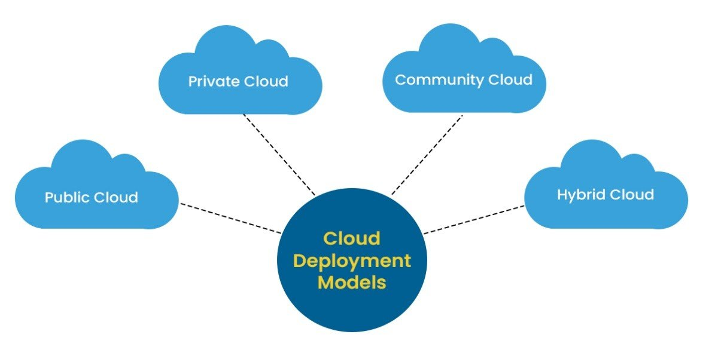

|  |  |
| --- | --- |
| *Cloud Models* | *Description* |
| Public Cloud | *The public cloud is available to anyone to store and access information over the Internet using the pay-per-sage method. In the public cloud, computing resources are managed and operated by cloud service providers (CSPs). Example: Amazon Elastic Compute Cloud (EC2), IBM Smart Cloud Enterprise, Microsoft, Google App Engine, Windows Azure service platform.* |
| Private Cloud | *Private clouds are also known as internal clouds or corporate clouds. Organizations use it to build and manage their own internal or third-party data centres. It can be deployed using open source tools such as Openstack and Eucalyptus. Based on location and management, the National Institute of Standards and Technology (NIST) divides the private cloud into two parts:*   * *On-premise private cloud* * *Outsourced private cloud* |
| Hybrid Cloud | *A hybrid cloud is a combination of a public cloud and a private cloud.*  ***Hybrid Cloud = Public Cloud + Private Cloud***  *The hybrid cloud is partially secure because anyone can access the services running in the public cloud, but the services running in the private cloud are organizations.*  ***Example****: Google Application Suite (Gmail, Google Apps, and Google Drive), Office 365 (MS Office on the web and OneDrive), Amazon Web Services* |
| Community Cloud | *Community Cloud allows groups of organizations to access systems and services to share information between organizations and specific communities. Owned, managed, and operated by one or more organizations, third parties, or a combination thereof within the community.*  ***Example:****Health Care community cloud* |

1. What are some cloud computing advantages?

|  |  |
| --- | --- |
| *Advantage* | *Description* |
| *Less Costs* | *The offerings are unfastened from capital expenditure. There aren't any massive prices of hardware in cloud computing. You simply need to pay as you use it and revel in the version primarily based totally on your subscription plan.* |
| *24 X 7 Availability* | *Availability Most of the cloud companies are actually dependable in supplying their offerings, with the maximum of them retaining an uptime of 99.9%. The people can get onto the packages wished essentially from everywhere. Some of the packages even feature offline.* |
| *Flexibility in Capacity* | *It gives bendy facility which might grow to become off, up or down as in step with the occasions of the person. For instance, advertising of income could be very popular, capability may be right now and fast brought to it for the avoidance of dropping income and crashing servers. When the one income is done, the capability also can be shrivelled for the discount of prices.* |
| *All over Functioning* | *Cloud computing gives but any other gain of running from everywhere throughout the globe, so long as you've got a web connection. Even as the usage of the crucial cloud offerings that provide cell apps, there's no obstacle to the tool used.* |
| *Automated Updates on Software* | *In cloud computing, the server providers frequently replace your software program together with the updates on protection, so you do now no longer want to be troubled about losing your critical time on retaining the system. You discover greater time to cognizance at the critical matters like `How to develop your businesses.* |
| *Security* | *Cloud computing gives high-quality protection whilst any touchy information has been misplaced. As the information is saved inside the system, it could be effortlessly accessed even supposing something takes place for your computer. You may even remotely wipe out information from the misplaced machines for keeping off it getting inside the incorrect hands.* |
| *Carbon Footprint* | *Cloud computing is assisting companies to lessen their carbon footprint. Organizations make use of the most effective number of assets they want, which allows them to keep away from any over-provisioning. Hence, no waste of assets and hence energy.* |
| *Enhanced Collaboration* | *Cloud packages beautify collaboration through authorizing numerous corporations of humans without a doubt to meet and change facts with the assistance of shared storage. Such functionality allows in enhancing the customer support and product improvement and additionally lowering the advertising time.* |
| *Control on the Documents* | *Before cloud got here into being, people had to ship documents inside and out as the e-mail attachments for being laboured on through an unmarried person at one time, in the long run, finishing up with a large number of opposite titles, formats, and record content. Moving to cloud computing has facilitated primary record storage.* |
| *Easily Manageable* | *Cloud computing gives simplified and more desirable IT renovation and control capacities through agreements sponsored through SLA, primary aid management and controlled infrastructure. You get to revel in a primary person interface with no requirement for installation. Plus you're confidently assured and well-timed control, renovation, and transport of the IT offerings.* |

1. Differentiate Capital expenses vs. operating expenses

*The state of enterprise IT has changed rapidly over the last decade, and enterprises are embracing the benefits of the cloud over on-premises data centres. Due to this shift, companies are seeing higher operating costs and lower capital investment.*

*Capital Expenditure (CapEx): This is the initial cash outlay (aggregate) on the physical infrastructure, after which its upfront spending is deducted over time. The initial cost of CapEx has a value that decreases over time. All costs incurred for future long-term profits are below capital investment.*

*Operating Expenses (OpEx): It's like a pay-as-you-go service. You can deduct these costs in the same year you used them. There is no initial cost as you pay when using the service or product. As the name implies, these are the costs of day-to-day operations.*

| *Context* | *Capital Expenditure* | *Operating Expenses* |
| --- | --- | --- |
| *The upfront cost* | *Significant* | *None* |
| *Ongoing cost* | *Low* | *Based on usage* |
| *Tax Deduction* | *Over-time* | *Same year* |
| *Early Termination* | *No* | *Anytime* |
| *Maintenance* | *Significant* | *Low* |
| *Value over time* | *Lowers* | *No change* |